Burlish Park
Primary School

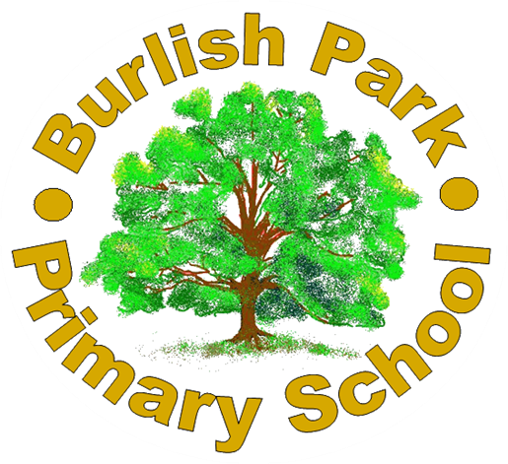
ALLERGEN INFORMATION

DATE: July 2025
REVIEW DATE: July 2026

Burlish Park Primary School recognises that a number of community members (pupils, parents, visitors and staff) may suffer from potentially life-threatening allergies or intolerances to certain foods. Burlish Park Primary School is committed to a whole school approach to the care and management of those members of the school community. The school’s position is not to guarantee a completely allergen free environment, rather to minimise the risk of exposure by hazard identification, instruction and information. This will encourage self-responsibility to all those with known allergens to make informed decisions on food choices and to provide help and assistance for our youngest pupils. The school has clear plans for an effective response to possible emergencies.

Allergy information:

True food allergies are reproducible adverse reactions to a particular food that involve the immune system. Virtually all known food allergens are proteins. They can be present in the food in large amounts and often survive food-processing conditions. Allergic reactions are characterised by the rapid release of chemicals in the body that cause symptoms, which can occur within minutes or up to an hour or more after ingestion of the allergen.

The common causes of allergies relevant to this policy are the 14 major food allergens:
• Cereals containing Gluten
• Celery including stalks, leaves, seeds and celeriac in salads
• Crustaceans, (prawns, crab, lobster, scampi, shrimp paste)
• Eggs - also food glazed with egg
• Fish - some salad dressings, relishes, fish sauce, some soy and Worcester sauces
• Soya (tofu, bean curd, soya flour)
• Milk and dairy - also food glazed with milk
• Nuts, (almonds, hazelnuts, walnuts, pecan nuts, Brazil nuts, pistachio, cashew and macadamia (Queensland) nuts, nut oils, marzipan)
• Peanuts - sauces, cakes, desserts, ground nut oil, peanut flour
• Mustard - liquid mustard, mustard powder, mustard seeds
• Sesame Seeds - bread, bread sticks, tahini, hummus, sesame oil
• Sulphur dioxide/Sulphites (dried fruit, fruit juice drinks)
• Lupin, seeds and flour, in some bread and pastries
• Molluscs, (mussels, whelks, oyster sauce, land snails and squid).

The allergy to nuts is the most common high risk allergy however, it is important to ensure that all allergies and intolerances are treated equally as the effect to the individual can be both life-threatening and uncomfortable, if suffered.

Burlish Park Primary School is committed to proactive risk food allergy management through:
- Ensuring that robust systems in place to ensure accurate and timely sharing of information relating to food allergies and intolerances with clearly defined responsibilities.
- Supporting pupils with the management of food allergies and intolerances.
- The encouragement of self-responsibility and learned avoidance strategies amongst those suffering from allergies.
- Working with our catering providers, Alliance in Partnership, sharing data with them, under GDPR law, as to children with food allergies.
- Provision of staff awareness on food allergies/intolerances, possible symptoms (including anaphylaxis) recognition and treatment.

Burlish Park Primary and Alliance in Partnership have a nut free and allergen policy. All menus are approved by dieticians. It is regularly advertised on the school newsletter and social media pages, that parents should not send their child into school with nuts in their lunch boxes. Parents should, however, be aware that there is no guarantee that a nut ban will ensure there are no nuts on school premises.

Burlish Park Wraparound operate a nut free policy. All food ingredients are scruitinised for the 14 allergens. Information on allergens is displayed for parents on the Wraparound entrances using the Public Health allergen chart. Dishes and their allergen content (food.gov.uk)

The school has a number of first aiders who would be called assist in cases of allergic reaction including anaphylaxis. A number of staff have also had training in how to administer an epi-pen to those children who have a Health Care Plan. The school will contact parents and the emergency services, if required, in the event that a child suffers an allergic reaction.

