Burlish Park
Primary School

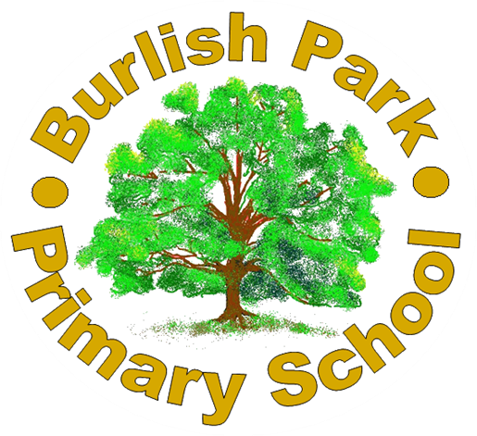
Nursery Admissions

DATE: July 2025
REVIEW DATE: July 2026

Burlish Park Primary School is part of the Rivers Multi Academy Trust. Parents and guardians wishing to apply for a place must complete the Burlish Park Primary School Nursery enrolment form, available from the school office or website and it should be submitted directly to the school.

Acceptance for a Nursery place does not guarantee admission to the main school. Separate Main School online admissions requests will need to be made to Worcestershire County Council at the appropriate time and subject to the admission criteria at that time.

Registration
- Applications are made directly to Burlish Park Primary School on the Nursery enrolment form available from the school website and office.
- Closing date for 1st September is 31st March.
- Closing date for January and Easter are as follows:

Requested Start Date | Closing Date for Applications
6th January | 23rd October
13th April | 12th February

- Parents for September will be advised if they have a place by the end of May.
- Parents for other requested start dates will be advised if they have a place at least one month before their chosen start date.
- Parents have ten working days to confirm acceptance. If no acceptance is received by the school, the offer is withdrawn without further notice. A new offer will be made to any other child on our waiting list.
- Parents cannot defer a place once offered although their request can go forward with the next round of applications if desired and subject to the admissions criteria.
- If demand is high, applicants may be unsuccessful. They will be informed of this in the term before their child would have entered Nursery. They will then have the option of being placed on a waiting list.

Admission Criteria
- An initial intake will allocate places to those children who will be 3 by the beginning of the term of admission.
- Further intakes are then offered to children who will be 3 in the term they wish to join (spaces permitting).
- In each category listed above, priority is given in the order of options below:
Option 1 | For those eligible for 30 hour funding:  Monday – Friday 8:50am-3pm
Option 2 | For 3 year olds eligible for 15 hour funding, either:  - Monday and Tuesday, 8.50am – 3pm, Wednesday 8.50am – 11.50am  or  - Wednesday 12.00pm – 3.00 pm, Thursday & Friday, 8.50am – 3pm  Extra sessions at available (spaces permitting) at £16.20 per half day session for children age 3 / £22.05 per half day session for children under 3.
Option 3 | Parents who would like to use funded childcare or pay for any sessions in any pattern. Please note these may be full days or half days depending on capacity. Paid sessions are at a cost of £16.20 per session or £22.05 per session for under 3s.

When admission to the Nursery is over-subscribed, applications for entry will be ranked according to the following criteria:
- Children “Looked After” (as defined in the Education Act 2002 – Admissions)
- 30 hour placements (Option 1) for those children who live in the catchment area of this school who will have a sibling attending this primary school at the time of the applicant’s proposed admission, who are living at the same address as part of the same family unit.
- 15 hour placements (Option 2) for those children who live in the catchment area of this school who will have a sibling attending this primary school at the time of the applicant’s proposed admission, who are living at the same address as part of the same family unit.
- 30 hour placements (Option 1) for those children who live in the catchment area of this school.
- 15 hour placements (Option 2) for those children who live in the catchment area of this school.
- 30 hour placements (Option 1) for those children who live outside the catchment area of this school, with a sibling attending this school at the time of the applicant’s proposed admission.
- 15 hour placements (Option 2) for those children who live outside the catchment area of this school, with a sibling attending this school at the time of the applicant’s proposed admission.
- 30 hour placements (Option 1) for those children who live outside the catchment area of this school who live the nearest calculated in a direct straight line from the child’s permanent place of residence to the school.
- 15 hour placements (Option 2) for those children who live outside the catchment area of this school who live the nearest calculated in a direct straight line from the child’s permanent place of residence to the school.
- Option 3 or requests for below the 15 hours provision.

Funding Eligibility
School offers a total of 30 hours and fifty minutes of free childcare per week, over 38 weeks (term time only)
Burlish Park Primary do not offer stretched funding over 52 weeks. The funded hours must be used throughout the 38 weeks of term time only. Therefore, the funding cannot be used for any care during the school holidays.

For more information on 30 hour funded places, please visit:
https://www.childcarechoices.gov.uk/

For more information on 15 hour funded places for 2 year olds, please visit:
http://www.worcestershire.gov.uk/info/20511/free_childcare_for_2_year_olds/1592/how_do_i_apply_for_a_2_year_old_place
Attendance
- We expect children to attend all booked sessions each week unless they are unwell.
- For safeguarding reasons, we may request proof of illness from parents of children who have higher than average level of absence due to illness (confirmation of GP appointment, prescription receipt etc.)
- If attendance falls below 85% the school reserves the right to remove the child from roll and offer the place to another child on the waiting list.

There will be an annual review of this policy by Senior Leadership Team.

